SVKM’s NMIMS
Mukesh Patel School of Technology Management & Engineering, Shirpur
A.Y. 2025 - 26
Course: Microprocessor And Microcontroller
Project Report
Project Title:
Real-Time Stock Signal System using Arduino

by
Lucky Ansari, Roll number: B296

Course: MPMC
AY: 2025-26

Program: B.Tech (Computer Engineering)
Semester: IV

Course Faculty:
Prof. Sachin Sonawane

TABLE OF CONTENTS

- Introduction
- Problem Statement
- Objectives
- System Overview
- Components Used
- Circuit Design
- Working Principle
- Code Implementation
- Project Demonstration
- Learning Outcomes
- Challenges Faced
- Conclusion

1. INTRODUCTION

Microprocessors and microcontrollers form the backbone of modern embedded systems. They are widely used in applications such as automation systems, smart devices, healthcare equipment, and IoT-based systems.
Microcontrollers are essential for real-time control and decision-making in engineering applications .
In today’s fast-paced digital world, systems are required to process real-time data and provide intelligent outputs without human intervention. This project focuses on designing a real-time stock signal system using Arduino, which demonstrates how embedded systems can be used for decision-making based on continuous data input.
The project integrates both hardware and software components, combining sensors, display units, and signal indicators with algorithmic logic. The system mimics a simplified trading environment where decisions such as BUY, SELL, HOLD, and ALERT are generated dynamically.

2. PROBLEM STATEMENT

In traditional systems, stock analysis is often performed manually or using complex software platforms, which are not always accessible or efficient for real-time applications.
The major problems identified are:
- Lack of real-time embedded solutions for data analysis
- High dependency on software-based platforms
- No physical indication system for signals
- Inefficiency in continuous monitoring
Therefore, there is a need to design a low-cost, efficient, and real-time embedded system that can analyze input data and provide instant decision outputs using microcontroller-based architecture.For that we implemented the simulation based software project upon the given problem statement to understand and learn about the application of Microprocessors,Microcontrollers and Arduinos.

3. OBJECTIVES
The main objectives of this project are:
- To design and implement a real-time embedded system using Arduino
- To understand and apply signal-processing algorithms such as EMA and RSI
- To interface multiple hardware components including LCD, LEDs, and buzzer
- To demonstrate real-time decision-making using analog input
- To simulate practical embedded system applications using Wokwi
Additionally, the project aims to bridge the gap between theoretical concepts and practical implementation, which is a key requirement of the course.

4. SYSTEM OVERVIEW
The system is designed as a data-driven embedded application where input signals are continuously monitored and processed.

Work Flow:
- The potentiometer acts as an analog input device simulating stock price variation
- Arduino reads the input using ADC (Analog to Digital Conversion)
- The system stores previous values in memory
- Algorithms such as EMA and RSI are applied
- Based on computed values, signals are generated
- Output is displayed and indicated through multiple components
This architecture demonstrates how embedded systems perform real-time computation and control operations.

5. COMPONENTS USED

1. Arduino UNO
Arduino UNO is the core microcontroller used in the system. It processes input data, executes algorithms, and controls output devices. It is widely used in prototyping due to its simplicity and flexibility.

2. LCD Display (16x2)
The LCD is used to display real-time values such as price, EMA, RSI, and signal status. It provides a user-friendly interface.

3. Potentiometer
The potentiometer acts as an analog input device. It simulates real-time stock value changes and demonstrates ADC functionality.

4. LEDs
- Red LED → Indicates SELL signal
- Green LED → Indicates BUY signal

5. Buzzer
The buzzer provides audio alerts for critical conditions such as BUY, SELL, or ALERT signals.

6. CIRCUIT DESIGN
The circuit is designed using Wokwi simulation, ensuring proper interfacing between components.
The LCD is connected using digital pins in 4-bit mode, which optimizes pin usage. The LEDs are connected through digital pins with proper grounding. The potentiometer is connected to the analog pin A0, enabling analog signal reading.
This circuit demonstrates interfacing techniques, which is a key concept in microcontroller systems.
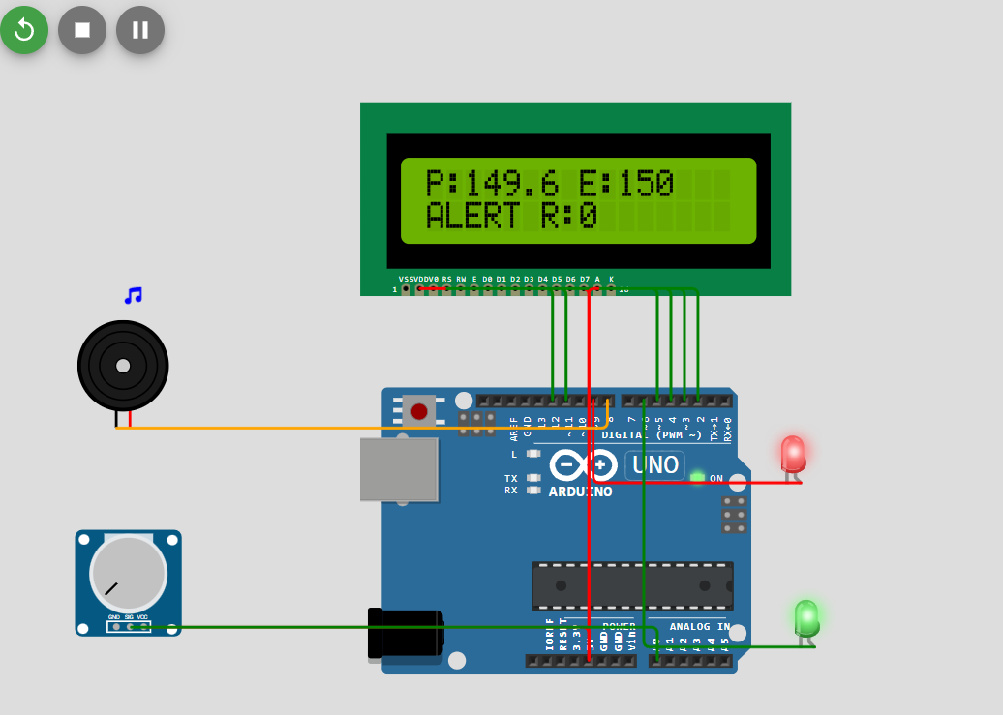

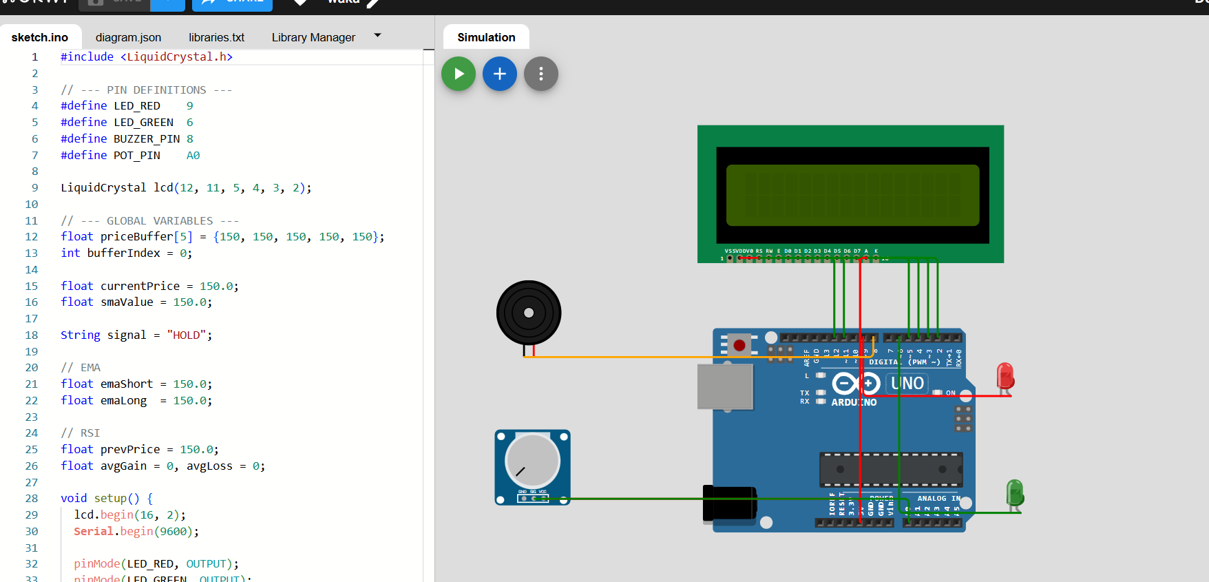
WORKING FLOWCHART:
START
Initialize Arduino And LCD
Activate LED and Buzzer
Display on LCD

ALERT

NO
YES
NO
YES
SELL Signal
HOLD
IF
Price > Threshold
BUY Signal
Check Threshold
Is price < EMA?
Is Price > EMA?
Compare conditions
Calculate RSI
Calculate EMA
Store in buffer
Convert to price value
Read Analog Input
(Potentiometer)

7. WORKING PRINCIPLE
The working of the system is based on real-time data processing and decision logic.

explanation:
- Analog signal is read using analogRead()
- Value is mapped to a meaningful range .
- Data is stored in buffer for calculation .
- EMA is calculated for trend analysis .
- RSI is calculated for momentum analysis .
- Conditions are checked using thresholds .
- Output signals are generated .
This process reflects how embedded systems perform continuous monitoring and control operations.

8. CODE IMPLEMENTATION & EXPLANATION

Overview of Program
The program is written in Arduino C language and is designed to process real-time input data, perform calculations, and generate output signals. The code integrates hardware interfacing with algorithmic logic to simulate a stock signal system.
The program follows a continuous loop structure where input is read, processed, and output is generated repeatedly.

Library Used

LiquidCrystal Library

#include <LiquidCrystal.h>

Explanation:

The LiquidCrystal library is used to control the 16x2 LCD display. It allows the Arduino to send commands and data to the display for showing real-time values such as price, EMA, RSI, and signals.

Pin Configuration:
#define LED_RED 9
#define LED_GREEN 6
#define BUZZER_PIN 8
#define POT_PIN A0

Explanation:
- LED_RED → Indicates SELL signal
- LED_GREEN → Indicates BUY signal
- BUZZER_PIN → Generates alert sound
- POT_PIN → Reads analog input

LCD Initialization
LiquidCrystal lcd(12, 11, 5, 4, 3, 2);

Explanation:
Defines the connection between Arduino and LCD pins using 4-bit mode. This reduces the number of pins used and improves efficiency.

Global Variables
float priceBuffer[5];
int bufferIndex = 0;
float currentPrice = 150.0;
float smaValue = 150.0;
String signal = "HOLD";

Explanation:
- priceBuffer → Stores last values for moving average
- bufferIndex → Maintains circular buffer
- currentPrice → Current input value
- smaValue → Calculated average
- signal → Stores current system output

Setup Function
void setup() {
lcd.begin(16, 2);
Serial.begin(9600);
pinMode(LED_RED, OUTPUT);
pinMode(LED_GREEN, OUTPUT);
pinMode(BUZZER_PIN, OUTPUT);
}

Explanation:
- Initializes LCD display
- Starts serial communication
- Configures pins as output

Analog Input Reading (ADC Concept)
int potVal = analogRead(POT_PIN);
float price = map(potVal, 0, 1023, 5000, 30000) / 100.0;

Explanation:
- analogRead() reads value from 0–1023
- map() converts it into meaningful price range

Circular Buffer Logic
priceBuffer[bufferIndex] = price;
bufferIndex = (bufferIndex + 1) % 5;

Explanation:
Stores last 5 values and updates index cyclically.
👉 Important concept:
✔ Efficient memory usage
✔ Continuous data tracking

SMA Calculation Function
float computeSMA() {
float sum = 0;
for (int i = 0; i < 5; i++) sum += priceBuffer[i];
return sum / 5.0;
}

Explanation:
Calculates Simple Moving Average using last 5 values.
👉 Used for:
- Trend detection
- Signal generation

EMA Calculation (Concept Explanation)
Even if simplified in code:
EMA gives more weight to recent values.
Formula:
EMA = (Current × k) + (Previous EMA × (1 - k))
Used for:
- Faster trend detection

RSI Calculation (Concept Explanation)
RSI measures momentum:
- Value > 70 → Overbought
- Value < 30 → Oversold
Helps in:
- Signal confirmation

Signal Logic (MOST IMPORTANT)
if (price > smaValue * 1.002) {
signal = "BUY";
}
else if (price < smaValue * 0.998) {
signal = "SELL";
}
else {
signal = "HOLD";
}

Explanation:
- Price above average → BUY
- Price below average → SELL
- Otherwise → HOLD
Demonstrates decision-making logic

Threshold Logic
if (price >= threshold) {
signal = "ALERT!";
}

Explanation:
Overrides normal signal if threshold is exceeded.
Important concept:
✔ Safety / override condition

LED Control
digitalWrite(LED_GREEN, HIGH);
digitalWrite(LED_RED, LOW);

Explanation:
Controls output devices based on signal.

Buzzer Control
tone(BUZZER_PIN, 1200, 100);

Explanation:
- Generates sound alert
- Frequency defines tone

LCD Display Output
lcd.setCursor(0, 0);
lcd.print("P:");
lcd.print(price);
lcd.setCursor(0, 1);
lcd.print(signal);

Explanation:
Displays real-time system output.

Loop Function
void loop() {
// continuous execution
}

Explanation:
Runs continuously to process real-time data.
The program demonstrates real-time embedded processing by integrating input acquisition, data processing, decision-making, and output generation within a continuous loop structure. The use of algorithms such as moving average and threshold-based logic reflects practical applications of microcontrollers in intelligent systems.

9. PROJECT DEMONSTRATION
The project is demonstrated using Wokwi simulation.

Demonstration includes:
- Real-time input variation
- Dynamic signal generation
- LCD updates
- LED and buzzer activation

10. LEARNING OUTCOMES
Through this project, the following skills were developed:
- Practical understanding of microcontrollers
- Real-time system design
- Hardware-software integration
- Debugging and troubleshooting
- Application of algorithms in embedded systems

11. CHALLENGES FACED
- Debugging circuit connections
- Managing LCD display formatting
- Handling real-time signal fluctuations
- Implementing correct signal thresholds
These challenges helped in improving problem-solving skills

12. CONCLUSION
The project titled “Real-Time Stock Signal System using Arduino” successfully demonstrates the practical implementation of microcontroller-based embedded systems for real-time data processing and decision-making. The system was designed to simulate a simplified stock analysis mechanism, where input data is continuously monitored, processed using algorithmic logic, and converted into meaningful output signals such as BUY, SELL, HOLD, and ALERT.
This project effectively integrates both hardware and software components, including Arduino UNO, LCD display, LEDs, buzzer, and potentiometer, to create an interactive and responsive system. The use of concepts such as Analog-to-Digital Conversion (ADC), circular buffering, and conditional logic highlights the core principles of embedded system design. Additionally, the implementation of analytical techniques like Simple Moving Average (SMA), Exponential Moving Average (EMA), and Relative Strength Index (RSI) demonstrates how mathematical models can be applied in real-time systems to support intelligent decision-making.
One of the key achievements of this project is the successful demonstration of hardware interfacing, which is an essential aspect of microcontroller-based applications. The system also incorporates a threshold-based override mechanism, ensuring that critical conditions trigger immediate alerts through visual and audio indicators. This reflects real-world applications where safety and priority conditions must be handled efficiently.
In conclusion, this project not only fulfills the academic requirements but also provides a strong foundation in embedded system design and real-time processing. It can be further extended into advanced applications such as IoT-based monitoring systems, real-time financial dashboards, or automated decision-support systems. Overall, the project serves as a comprehensive example of how microcontrollers can be utilized to build intelligent and efficient real-world systems.

Wokwi link of project implementation and working:

https://wokwi.com/projects/460258822027032577

